4.9 Activity Diagram – User Login
Description
The User Login Activity Diagram describes the workflow of the authentication process. It starts when the user enters login credentials, the system validates them, and then either grants access or displays an error message depending on the verification result.
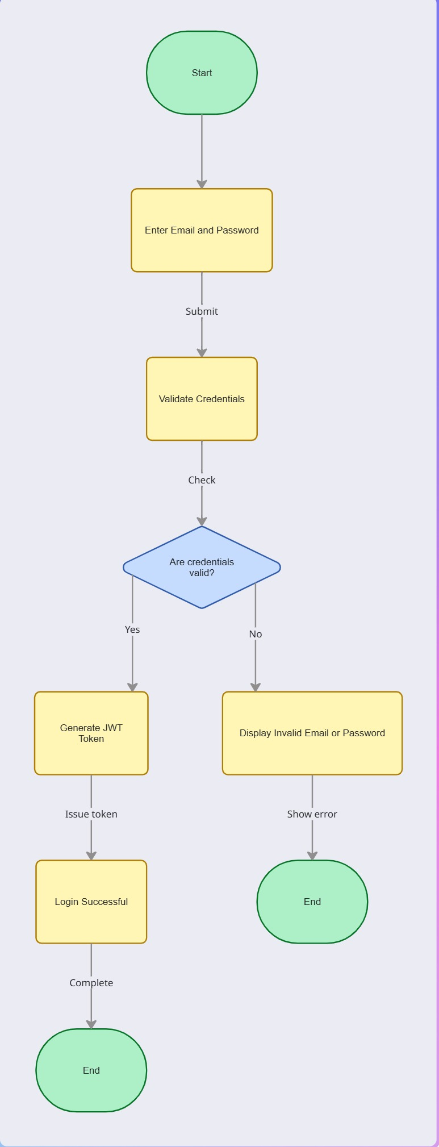

4.10 Activity Diagram – Book Appointment
Description
The Book Appointment Activity Diagram illustrates the workflow followed when a patient books an appointment. The patient selects a doctor, chooses a service, specifies the preferred date and time, and the system checks the doctor's availability. If the selected time is available, the appointment is created and a confirmation notification is sent to the patient. Otherwise, the patient is asked to choose another appointment time.
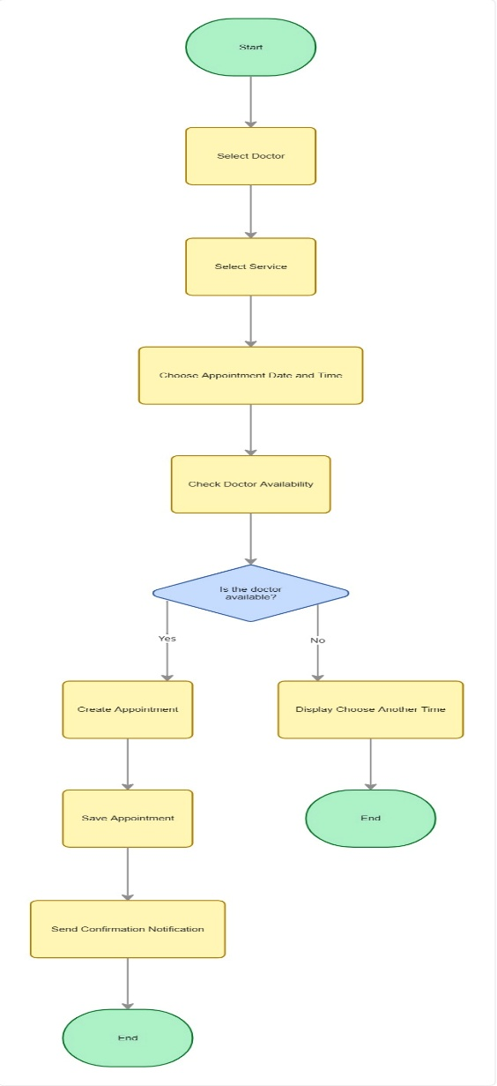

4.11 Activity Diagram – Create Medical Report & Prescription
Description
The Create Medical Report & Prescription Activity Diagram illustrates the workflow performed by the doctor after examining a patient. The doctor creates a medical report and a prescription, then the system stores both records in the PostgreSQL database and notifies the patient that the report and prescription are available.

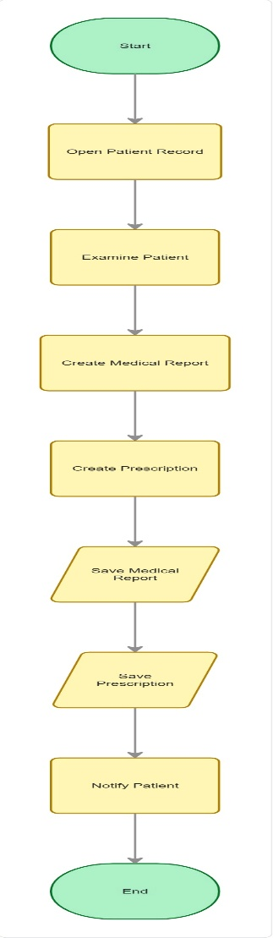

4.12 Activity Diagram – Manage Appointment
Description
The Manage Appointment Activity Diagram illustrates the workflow used by the administrator to manage patient appointments. The administrator can either confirm or cancel an appointment. After updating the appointment status, the system sends the appropriate notification to the patient and completes the process.
